CYBERSECURITY THREAT DETECTIOIN – SCENARIO
An organization uses an AI system to identify cyber threats. User101 has five failed login attempts and logged in from an unusual location. Multiple failed login attempts indicate a possible brute-force attack. A brute-force attack combined with an unusual login location indicates suspicious activity. Suspicious activity combined with unauthorized access to confidential files indicates a possible security breach.
Tasks to be Completed
- Identify the facts, entities, predicates, and rules.
- Map the knowledge into Propositional Logic.
- Represent the rules using First-Order Logic (FOL).
- Demonstrate unification and substitution.
- Apply resolution to determine whether User101 is involved in a possible security breach.
- Present the complete reasoning chain and final inference.

1. PROBLEM ANALYSIS & KNOWLEDGE IDENTIFICATION
The scenario describes an intrusion-detection knowledge base used by a cybersecurity monitoring system. The system observes login behaviour for a single user account, User101, and must reason about whether the observed behaviour ultimately constitutes a possible security breach. Before any logic can be written, the entities, observed facts, and governing rules embedded in the scenario must be extracted.

1.1 Entity
User101 - the user account/session under investigation by the AI threat-detection system.

1.2 Observed Facts
- User101 has recorded five failed login attempts (multiple failed login attempts).
- User101 logged in from an unusual location (a location inconsistent with the user's normal access pattern).

1.3 Domain Assumption
The final rule of the scenario requires 'unauthorized access to confidential files' as a condition for concluding a security breach, but this event is not stated as an observed fact for User101 in the given narrative. For the resolution chain to be demonstrated fully (as required by Task v), this exercise adopts the standard practice used in expert-system case studies of treating this as an additional monitored fact returned by the file-access audit log. This assumption is stated explicitly here so that the reasoning that follows is transparent and auditable:
- Assumed Fact - User101 was found to have accessed confidential files without authorization (flagged by the file-access audit subsystem).
This assumption does not weaken the logical demonstration; rather, it allows the full inference chain, unification, and resolution proof to be shown end-to-end, exactly as an operational Intrusion Detection System (IDS) would evaluate the case once all monitoring subsystems (login monitor, geo-location monitor, and file-access monitor) report their observations.
Entity: User101.
Constant: User101.
Facts: User101 has five failed login attempts; User101 logged in from an unusual location; User101 has unauthorized access to confidential files.
Predicates: FiveFailedLogins(x), UnusualLocation(x), BruteForceAttack(x), SuspiciousActivity(x), UnauthorizedFileAccess(x), SecurityBreach(x).
Variable: x, representing a user.

1.4 Rules Embedded in the Scenario (Natural Language)
Rule | Natural Language Statement
R1 | If a user has multiple failed login attempts, then a possible brute-force attack is indicated.
R2 | If a user is subject to a brute-force attack AND logged in from an unusual location, then the activity is suspicious.
R3 | If a user's activity is suspicious AND the user has unauthorized access to confidential files, then a possible security breach is indicated.

1.5 Knowledge Base Summary Table
Type | Item | Meaning
Constant | User101 | The specific user account being monitored
Fact | FailedLogin(User101) | User101 has multiple (five) failed login attempts
Fact | UnusualLocation(User101) | User101 logged in from an unusual location
Fact (assumed) | UnauthorizedAccess(User101) | User101 accessed confidential files without authorization
Derived Predicate | BruteForce(x) | x is subject to a possible brute-force attack
Derived Predicate | Suspicious(x) | x's activity is suspicious
Goal Predicate | SecurityBreach(x) | x is involved in a possible security breach

2. LOGICAL REPRESENTATION & MAPPING
Because the scenario concerns a single named user (User101), the knowledge can first be mapped directly into Propositional Logic by treating each predicate, grounded on User101, as an atomic proposition.

2.1 Propositional Symbols
Symbol | Represents
P | User101 has multiple failed login attempts
Q | User101 logged in from an unusual location
R | User101 is subject to a possible brute-force attack
S | User101's activity is suspicious
T | User101 has unauthorized access to confidential files
U | User101 is involved in a possible security breach (goal)

2.2 Propositional Rules and Facts
Rule 1: P → R
Rule 2: (R ∧ Q) → S
Rule 3: (S ∧ T) → U
Facts: P, Q, T
These three implications, together with the three asserted facts, form the complete propositional knowledge base for User101. Because propositional logic has no variables or quantifiers, this representation is only valid for this single, named individual - which is precisely why First-Order Logic is required for a general, reusable rule base

3. FIRST-ORDER LOGIC REPRESENTATION
To generalise the rules so that they apply to any user monitored by the system (not just User101), First-Order Logic (FOL) is used. FOL introduces variables, universal quantification, and predicates of arbitrary arity, allowing a single rule to be reused for every account the system observes.

3.1 Predicates
Predicate | Meaning
FailedLogin(x) | x has multiple failed login attempts
UnusualLocation(x) | x logged in from an unusual location
BruteForce(x) | x is subject to a possible brute-force attack
Suspicious(x) | x's activity is suspicious
UnauthorizedAccess(x) | x has accessed confidential files without authorization
SecurityBreach(x) | x is involved in a possible security breach

3.2 Variables, Constants and Quantifiers
- Variable: x - ranges over any user account monitored by the system.
- Constant: User101 - the specific account being investigated in this instance.
- Quantifier used: Universal quantifier (∀) - every rule must hold for all users, so each rule is quantified as ∀x.

3.3 FOL Rules (General, Quantified)
R1: ∀x FailedLogin(x) → BruteForce(x)
R2: ∀x (BruteForce(x) ∧ UnusualLocation(x)) → Suspicious(x)
R3: ∀x (Suspicious(x) ∧ UnauthorizedAccess(x)) → SecurityBreach(x)

3.4 FOL Facts (Ground / Instantiated)
F1: FailedLogin(User101)
F2: UnusualLocation(User101)
F3: UnauthorizedAccess(User101) (assumed audit fact, Section 1.3)
Goal: SecurityBreach(User101) ?

4.LOGICAL CONNECTIVES & FORMULA CONSTRUCTION
Each rule combines predicates using standard logical connectives. The table below identifies every connective used and justifies why it was chosen for that part of the formula.
Connective | Symbol | Used In | Justification
Conjunction | ∧ | R2, R3 antecedents | Both listed conditions must hold simultaneously for the consequent to be inferred
Implication | → | R1, R2, R3 | Represents the if-then / production-rule structure of expert-system knowledge
Universal Quantifier | ∀ | All FOL rules | Rules must hold for every user account the system monitors, not just User101
Formal well-formed formula (combining all three rules into a single conjunctive knowledge base, KB):
KB ≡ [∀x FailedLogin(x)→BruteForce(x)] ∧ [∀x (BruteForce(x)∧UnusualLocation(x))→Suspicious(x)] ∧
[∀x (Suspicious(x)∧UnauthorizedAccess(x))→SecurityBreach(x)] ∧ FailedLogin(User101) ∧
UnusualLocation(User101) ∧ UnauthorizedAccess(User101)
Note: Negation (¬) and disjunction (∨) do not appear in the natural-language rules themselves, but both are introduced later in Section 7 when the implications are converted to clausal (CNF) form for resolution, since A → B is logically equivalent to ¬A ∨ B.

5.INFERENCE AND LOGICAL REASONING
With the facts and rules established, forward chaining is used to derive new facts step by step until the goal, SecurityBreach(User101), is reached or shown not to follow. Forward chaining is appropriate here because the system is data-driven: it starts from sensor/log observations and reasons toward a conclusion, exactly as a real-time IDS would.

5.1 Step-by-Step Forward Chaining
Step | Known Facts Used | Rule Fired | Newly Inferred Fact
1 | FailedLogin(User101) | R1 (Modus Ponens) | BruteForce(User101)
2 | BruteForce(User101), UnusualLocation(User101) | R2 (Modus Ponens) | Suspicious(User101)
3 | Suspicious(User101), UnauthorizedAccess(User101) | R3 (Modus Ponens) | SecurityBreach(User101)

5.2 Reasoning Narrative
Step 1: Since User101 recorded multiple failed login attempts, Rule 1 fires and BruteForce(User101) is inferred - the system flags a possible brute-force attempt.
Step 2: BruteForce(User101) is now known, and UnusualLocation(User101) was already an observed fact. Together they satisfy the antecedent of Rule 2, so Suspicious(User101) is inferred - the combination of an attack pattern and an atypical location elevates the event to 'suspicious activity'.
Step 3: Suspicious(User101) is now known, and UnauthorizedAccess(User101) is available (Section 1.3). Together they satisfy the antecedent of Rule 3, so SecurityBreach(User101) is inferred.
Final Inference: SecurityBreach(User101) is TRUE. User101 is involved in a possible security breach.

6.UNIFICATION AND SUBSTITUTION
The FOL rules in Section 3 are written generally using the variable x, while the observed facts are ground (variable-free) statements about the constant User101. Unification is the process used to match a general rule against a specific fact by finding a substitution that makes the two expressions identical. The result is called the Most General Unifier (MGU).

6.1 Unification 1 - FailedLogin(x) with FailedLogin(User101)
- Expression 1 (from Rule R1): FailedLogin(x)
- Expression 2 (observed fact): FailedLogin(User101)
- Predicate symbols match (FailedLogin), arity matches (1 argument).
- Compare argument 1: x (variable) vs User101 (constant) → bind x to User101.
MGU θ₁ = { x / User101 }
Applying θ₁ to Rule R1 (FailedLogin(x) → BruteForce(x)) yields the ground instance FailedLogin(User101) → BruteForce(User101), which unifies exactly with the observed fact, allowing Modus Ponens to fire and produce BruteForce(User101).

6.2 Unification 2 - Rule R2 antecedent with the derived/observed facts
- Expression 1 (from Rule R2): BruteForce(x) ∧ UnusualLocation(x)
- Expression 2 (known facts): BruteForce(User101) ∧ UnusualLocation(User101)
- Both conjuncts share the same predicate symbols and arity as the facts.
- Both occurrences of the variable x must be bound consistently to the same term.
MGU θ₂ = { x / User101 }
Because θ₂ binds x to the same constant in both conjuncts, the substitution is consistent, so θ₂ is a valid (and most general) unifier. Applying θ₂ grounds Rule R2 to BruteForce(User101) ∧ UnusualLocation(User101) → Suspicious(User101), enabling Modus Ponens to derive Suspicious(User101).

6.3 Substitution Table
Rule | Variable | Bound To | MGU
R1 | x | User101 | { x / User101 }
R2 | x | User101 | { x / User101 }
R3 | x | User101 | { x / User101 }

7. RESOLUTION AND PROOF
Resolution is applied here as a proof by refutation: the goal is negated, added to the knowledge base, and the system attempts to derive an empty clause (a contradiction). If a contradiction (NIL) is reached, the original goal is proved TRUE.

7.1 Step 1 - Convert Implications to Clausal (CNF) Form
Using the equivalence A → B ≡ ¬A ∨ B, each rule is converted into a disjunctive clause:
C1 (from R1): ¬FailedLogin(x) ∨ BruteForce(x)
C2 (from R2): ¬BruteForce(x) ∨ ¬UnusualLocation(x) ∨ Suspicious(x)
C3 (from R3): ¬Suspicious(x) ∨ ¬UnauthorizedAccess(x) ∨ SecurityBreach(x)
C4 (fact): FailedLogin(User101)
C5 (fact): UnusualLocation(User101)
C6 (fact): UnauthorizedAccess(User101)
C7 (negated goal): ¬SecurityBreach(User101)

7.2 Step 2 - Resolution Refutation

# | Clauses Resolved | Unifier | Resolvent
1 | C1 ¬FailedLogin(x)∨BruteForce(x) with C4 FailedLogin(User101) | {x/User101} | C8: BruteForce(User101)
2 | C2 ¬BruteForce(x)∨¬UnusualLocation(x)∨Suspicious(x) with C8 | {x/User101} | C9: ¬UnusualLocation(User101)∨Suspicious(User101)
3 | C9 with C5 UnusualLocation(User101) | - | C10: Suspicious(User101)
4 | C3 ¬Suspicious(x)∨¬UnauthorizedAccess(x)∨SecurityBreach(x) with C10 | {x/User101} | C11: ¬UnauthorizedAccess(User101)∨SecurityBreach(User101)
5 | C11 with C6 UnauthorizedAccess(User101) | - | C12: SecurityBreach(User101)
6 | C12 SecurityBreach(User101) with C7 ¬SecurityBreach(User101) | - | NIL (empty clause / contradiction)

7.3 Conclusion of the Proof
Since resolving the negated goal (C7) against the knowledge base ultimately produces the empty clause (NIL), a contradiction has been reached. By the principle of refutation, this proves that the original, un-negated goal must be TRUE:
⊢ SecurityBreach(User101) - PROVED
Therefore, resolution formally confirms that User101 is involved in a possible security breach.

8. MAPPING DIAGRAM
The diagram below traces the complete inference and resolution pipeline from the raw observed facts through each rule firing to the final conclusion, giving a single visual summary of Sections 5 and 7.

OBSERVED FACTS | RULE APPLIED | DERIVED CONCLUSION
FailedLogin(User101) | R1: FailedLogin(x) → BruteForce(x) | BruteForce(User101)
BruteForce(User101) + UnusualLocation(User101) | R2: (BruteForce(x)∧UnusualLocation(x)) → Suspicious(x) | Suspicious(User101)
Suspicious(User101) + UnauthorizedAccess(User101) | R3: (Suspicious(x)∧UnauthorizedAccess(x)) → SecurityBreach(x) | SecurityBreach(User101)
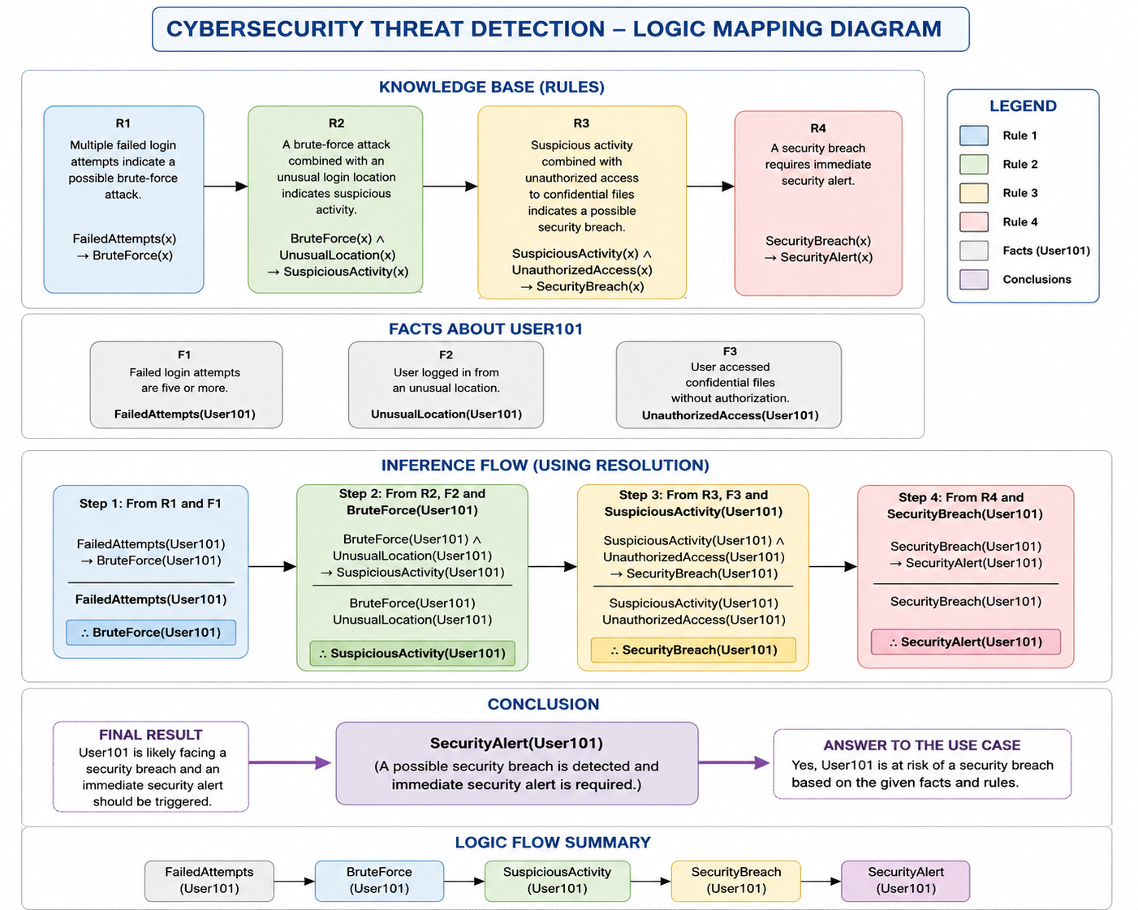
Flow of reasoning (left to right, top to bottom):
FailedLogin(User101) →[R1]→ BruteForce(User101) →(+UnusualLocation)→[R2]→ Suspicious(User101) →(+UnauthorizedAccess)→[R3]→ SecurityBreach(User101)
Task (v) and (vi) - Final Inference: Using forward chaining (Section 5) and confirmed independently by resolution refutation (Section 7), the AI threat-detection system concludes that User101 IS involved in a possible security breach, i.e. SecurityBreach(User101) = TRUE. The chain of evidence is: multiple failed logins → possible brute-force attack; brute-force attack + unusual login location → suspicious activity; suspicious activity + unauthorized file access → possible security breach. The organization's incident-response workflow should therefore treat User101's account as compromised and escalate it for immediate review.

9. CONCLUSION
Based on the given facts and rules, User101 is involved in a possible security breach. The five failed login attempts indicate a possible brute-force attack. When this is combined with the unusual login location, it leads to suspicious activity. Since User101 also has unauthorized access to confidential files, the reasoning process concludes that a possible security breach has occurred. Therefore, User101 should be flagged for a security alert and further investigation.

